THE UNITED REPUBLIC OF TANZANIA
PRESIDENT’S OFFICE
REGIONAL ADMINISTRATION AND LOCAL GOVERNMENT
KAGERA REGION
FORM FOUR MOCK EXAMINATION MAY, 2020
MARKING SCHEME
012 HISTORY
- (1mark@)=15
E | C | E | B | C | A | D | C | B | C | D | A | A | E | A

- (1mark@)=5
C | E | H | D | A

- (2mark@)=12 Total
- NEOLITHIC REVOLUTION; was an era that existed between the late stone age and iron age that was characterized by great changes in human development, it existed between 5000bc and 1000ad and at first it was noted in Egypt. E.g. Of notable changes were agricultural development surplus production population growth and rise f permanent settlement.
- UBUSOKA CEREMONY; was one of the traditional ceremony that was conducted in order to pass in new leadership and throwing out the old one, this was one of the traditional cultural practices in political organization in pre colonial African societies. E.g. it was done in the pastoral societies like the Maasai and the semi agrarian societies like the nyakyusa.
- COLONIAL TRANSPORT INFRUSTRUCTURE; these were physical or economic patterns that were laid up(constructed) by the colonialist during the colonial rule in the colonies like roads railways ports and harbors to transport raw materials agricultural implements troops officials labors and linking administrative areas e.g. Tanga moshi railway (1883-89) Mombasa Nairobi railway.
- LONG DISTANCE TRADE; was regional trade conducted by eastern and southern African societies which involved long journey in distance areas for exchange of goods in 200bc ,it involved yao kamba and nyamwezi. E.g. Items like ivory slaves tortoiseshell were exchanged.
- INDIAN BANYANS; were the rich traders along the east African coast who had a lot of money and money lenders for buying slaves and selling to American merchants, majority of them were Arabs Indian Asian and some European. E.g. they supplied money to local traders like ahmad Mohamed bin mujereb (tiputipu) and other Swahili traders to buy for them slaves in the hinter land (interior parts)
- INDUSTRIAL CAPITALISM; was the second stage in the development of capitalism in Europe started in 1750 in Britain during the transition from mercantilism to competitive capitalism, it was noted by the introduction of machines (factory system) that replaced the old traditional feudal guild and cottage industries.eg of countries which undergo industrial capitalism by 1850s were France England and Italy.

- (2mark@)=12 Re-arranging facts
2 | 5 | 4 | 1 | 6 | 3

- Map analysis(2mark@)=10, good drawing 1mark
- ………….
- ………….
- …………
- …………..
- ……………
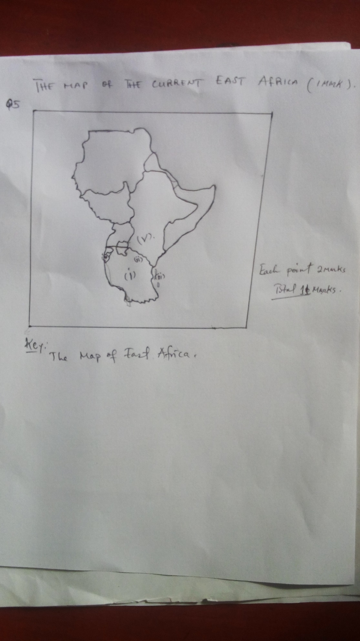
6. Significances of majimaji war of 1905-1907
A) INTRODUCTION;( 2mark) majimaji war was a mass African revolts in southern Tanganyika against the Germans lead by kinjekitile ngwale,it covered six region of southern Tanzania with 20 tribes like matumbi zaramo rungu etc.
B) Main body(2mark@) =12
- Promoted unity among the people of Tanganyika as it involved about 20 tribes.
- Helped people of Tanganyika to change movement techniques to diplomatic manners
- Created a colonial mind reform to the Germans e.g. on hoe to govern the ruled people
- It taught Tanzanian the role of leadership as it was so vital in any struggle
- Helped people to ignore local believes and witch craft as it was useless
- It laid a room for further nationalism struggle as it created the spirit of awareness and consciousness to people of Tanganyika
- It helped to lower exploitation to people of Tanganyika like through land alienation was reduced in the southern region.
C) CONCLUSION (1mark) The candidate may give some general effects of majimaji war to the people of southern Tanganyika
7. The candidate is required to describe meaning of iron and how was it sdiscovered (2mark) and state its uses such as (2mark@)12
- To make agricultural tools e.g. pangas, hoes and axes
- To make weapons e.g. swords, arrows and spears
- Medium of exchange
- Measure of wealth
- To make musical instruments e.g. bells, gongs, and cymbals
- Make jewelers items such as necklaces, bracelets, and bangles
Conclusion (1mark)
8. The candidate is required to elaborate African Unity, political unity(2mark) and state points such as follows and related points(2mark@)=12
- Colonial legacy
- Atmosphere in which freedom movements operated
- Political ideologies
- The challenge of national building
- Time for independence at different territories
Conclusion(1mark)
9.why indirect rule.
A) INTRODUCTION (2mark) the student should give the meaning of in direct rule ,state when it was introduced e.g., 1925 by sir Donald Cameroon also French changed to indirect rule association policy by 1920s
B)MAIN BODY.(2mark@)=12
- Reducing some costs of administration because it was cheap and more profitable by having interpreters tax collectors and other officials
- Helped to remove the problem of administrators because British population was very small while they have many colonies
- Helped to solve the language problem because African used their vernacular languages
- To reduce African resistance as it hide the real enemy to the ruled
- To reduce contradicting African traditional rules and customs through the use of local chiefs
- To serve the British racial regime because not many British were brought to the colonies like the case of French in assimilation policy
- It gave a chance to intensive exploitation due to close grassroots supervision like tax collection and forced labor.
- Extension of colonialism as it made British to rule their colonies for long time before people’s awareness of decolonization.
C) CONCLUSION (1mark) a candidate may explain the effects of in direct rule to the colonized

